**Anymaze**

Webinar session 1 <https://www.youtube.com/watch?v=dQU5yfiDg1Y> *[Important & helpful to watch]*

Webinar session2 https://www.youtube.com/watch?v=n8rudj4j50Y

Anymaze downloads <http://www.anymaze.co.uk/anymaze-downloads.htm>

Camera for ANY-MAZE <http://www.anymaze.co.uk/choosing-a-camera-for-any-maze.pdf>

*(Helpful to determine the distance of the camera from the maze)*

Anymaze features <http://www.anymaze.co.uk/anymaze-features.htm>

Anymaze 6.1 software download for practice

<https://www.stoeltingco.com/anymaze/video-tracking/software/any-maze-video-tracking-software-1218.html>

*(Prompts you to set up login/password at the end*)

The software will look like a Word document

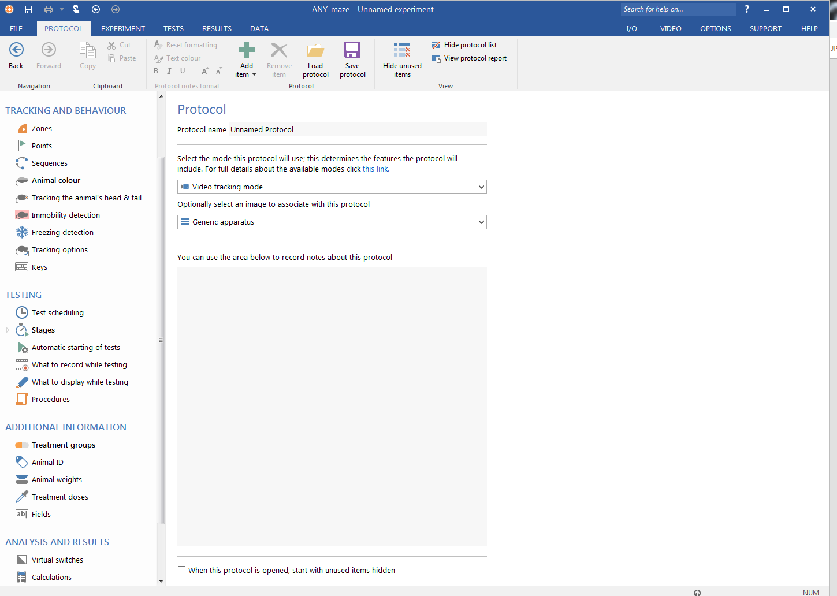

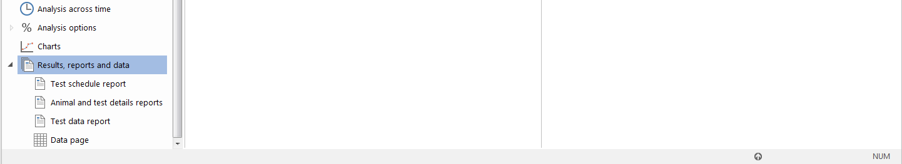

Go to **HELP** tab and see **Getting Started** and **Any-maze reference** for the detailed manual. You can also save the whole manual as pdf from **Print** icon. [The manual is simple but very detailed: 2018 pages and 10.1 MB] 